No.: | 2060

Nanjing University of Posts and Telecommunications


TCP/IP网络设计与实现（双语）论文
Implementation-Oriented Analysis of the TCP Protocol

Student No.: B23041026
Name: 袁衡
Submission date: 2026-07-02
Lecturer: 叶晓国

Course Goals / Evaluation Criteria |  | Grade
Course Goal 1： Understanding the purpose of the specified protocol, including explain the specific role it plays within the application and the problems it addresses. (20 Points) |  | 16
Course Goal 2： Understanding the corresponding code, including the components that make up the code implementing protocol functionality, and the specific functions of each part. (20 Points) |  | 16
Course Goal 3：Master the core data structure and implementation ideas of specific protocols. (20 Points) |  | 16
Course Goal 4：Understand how the specified protocol interacts with other protocols or other OSI layers. (20 Points) |  | 16
Course Goal 5：Possess expression and word processing skills, able to write reports with detailed and standardized report content. (20 Points) |  | 16
Totally |  | 80
Comments（评语）:
该同学按照要求对***协议代码的数据结构、执行流程及其调用关系进行了分析，（基本、较好地、圆满）完成了大作业的撰写任务，大作业报告层次清晰，图表（较）完整，报告中对代码模块间的调用关系的分析（不够、较）深入，该同学大作业论文撰写态度较认真，撰写（基本、较）规范。

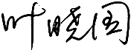 | 2026-07-05

Implementation-Oriented Analysis of the TCP Protocol in 4.4BSD-Lite
Abstract—Transmission Control Protocol (TCP) remains the dominant transport protocol for applications that require a reliable, ordered, full-duplex byte stream over an unreliable packet-switched network. This paper studies TCP from an implementation-oriented perspective, using the 4.4BSD-Lite networking code discussed in TCP/IP Illustrated, Volume 2 as the primary implementation object and the IETF TCP standards as the normative protocol baseline. Rather than repeating only the abstract service properties of TCP, the analysis traces how these properties are realized by concrete kernel structures, including socket, sockbuf, inpcb, tcpcb, mbuf, protosw and timer state. The paper further examines the interactions among tcp_input, tcp_output, tcp_usrreq, tcp_timer and the socket layer, and explains how connection establishment, state transition, acknowledgement processing, flow control, congestion control and retransmission are coupled through the TCP control block. The resulting view shows that TCP correctness is not concentrated in a single routine; it emerges from a disciplined division of responsibility across protocol demultiplexing, per-connection state, memory buffering, timers and IP-layer output.
Keywords—TCP implementation; 4.4BSD-Lite; protocol control block; finite state machine; retransmission timer; congestion control; socket layer.
- Introduction
TCP was originally specified as a reliable host-to-host transport protocol for packet-switched internetworks, and the modern TCP specification consolidates decades of updates while preserving the same core abstraction: an application observes a byte stream, whereas the network carries independently routed IP datagrams [3], [4]. This abstraction solves four practical problems for applications. First, it transforms an unreliable datagram substrate into reliable, in-order delivery through sequence numbers, acknowledgements and retransmission. Second, it multiplexes multiple application conversations by using port numbers and protocol control blocks. Third, it regulates the rate of communication with receiver-side flow control and sender-side congestion control. Fourth, it provides a connection lifecycle that allows both endpoints and the operating system to allocate, identify, drain and finally reclaim connection state.
The selected topic is the implementation of TCP in 4.4BSD-Lite. This topic is more suitable for the present course assignment than a purely descriptive protocol overview because it exposes the internal data structures and code paths behind the protocol. The implementation discussed in TCP/IP Illustrated, Volume 2 is compact enough to be analyzed within a term-paper scope, yet complete enough to cover socket interaction, PCB management, header processing, finite-state transitions, timers, congestion-window variables and memory buffers [1]. In addition, TCP has a rich standards record, including RFC 9293, RFC 5681 and RFC 6298, which allows implementation details to be evaluated against protocol requirements rather than only against textbook descriptions [3], [6], [7].
The contribution of this paper is therefore a data-structure-centered analysis. The following sections first summarize the protocol purpose and service model, then discuss the BSD networking architecture, the major TCP code modules, the core control blocks and the execution flow. Finally, the paper evaluates the advantages and limitations of the classic BSD implementation and suggests improvement directions grounded in current TCP standards and deployment practice.
- Protocol Function and Design Rationale

Service Model
TCP exports a reliable, ordered byte stream between two endpoints identified by a four-tuple: local IP address, local port, foreign IP address and foreign port. Unlike UDP, TCP is connection-oriented and keeps substantial per-connection state. This state records the send and receive sequence spaces, advertised windows, timers, retransmission counters and flags that determine whether a segment should be accepted, acknowledged, retransmitted or used to drive a state transition. At the application boundary, this complexity is hidden behind the socket API. A web server, SSH daemon or database client does not manipulate sequence numbers directly; it writes bytes to a socket and expects the kernel to segment, transmit, recover and deliver the stream.
The reliability model is cumulative. The sender attaches sequence numbers to the byte stream, while the receiver returns acknowledgements for the next byte expected. If an acknowledgement is delayed or absent, timers trigger retransmission. This mechanism alone would be insufficient on a shared network, because an aggressive retransmission policy can amplify congestion. Therefore, TCP also includes congestion control. RFC 5681 defines slow start, congestion avoidance, fast retransmit and fast recovery as the classic intertwined algorithms, and it introduces the sender-side congestion window as an additional limit on data in flight [6]. In 4.4BSD-Lite, these ideas appear as variables in the TCP control block, notably snd_cwnd and snd_ssthresh.

Why the Implementation Is Structurally Interesting
A TCP implementation is structurally interesting because it must connect three levels of abstraction. At the top, the application sees socket system calls such as connect, listen, accept, send, recv and close. In the middle, TCP uses per-connection state and a finite state machine to implement the protocol rules. At the bottom, IP output, interface drivers and mbuf chains provide packet transmission. A correct implementation must maintain invariants across all three levels: a descriptor must identify the correct socket, the socket must point to the correct protocol control block, the control block must represent the correct peer endpoint and state, and the packet emitted to IP must be consistent with the current send window and TCP flags.
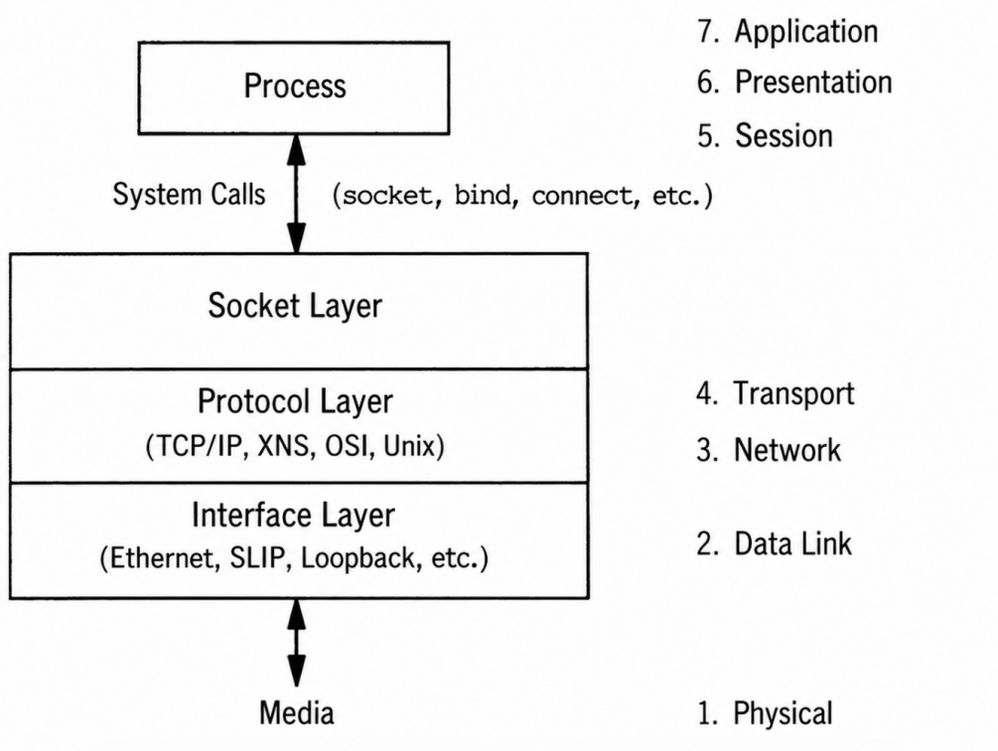
- Net/3 networking code organization. Original source: TCP/IP Illustrated, Vol. 2, Fig. 1-3 [1].
- Overall Design in the BSD Networking Architecture
The BSD networking stack organizes network code into a protocol-independent socket layer, protocol-specific implementations and device-interface code. This organization is significant for TCP because the same system-call interface is shared by several protocol families, but TCP-specific semantics are implemented below the socket layer. The socket layer performs descriptor validation, argument copying and generic buffer management. The TCP layer performs connection establishment, stream sequencing, retransmission, acknowledgement and congestion control. The IP layer provides datagram delivery, routing and fragmentation, while the link layer finally transmits frames on the medium.
The descriptor-to-socket mapping is the first implementation bridge. A process holds a small integer descriptor. The descriptor indexes the process file-descriptor table, which points to a file structure. For sockets, the file structure points to a socket structure. The socket then points through so_pcb to protocol-specific state. This chain explains why socket I/O can be treated similarly to file I/O at the process level, while still allowing protocol-specific behavior underneath.

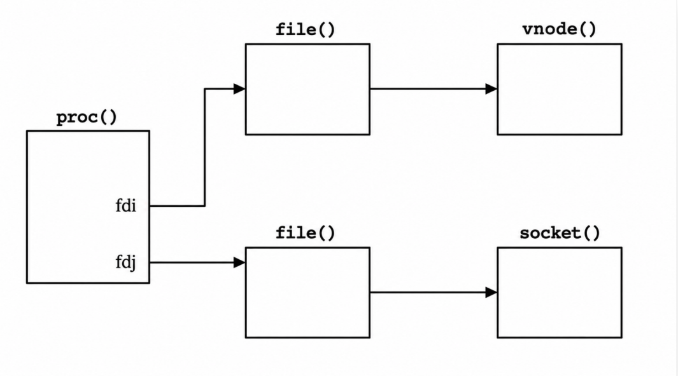
- Descriptor, file table and socket relation in the BSD kernel. Original source: TCP/IP Illustrated, Vol. 2, Fig. 1-4 [1].
For TCP, the protocol control hierarchy is two-level. The Internet PCB, inpcb, stores address and port information common to UDP and TCP, while tcpcb stores TCP-specific state. The socket points to inpcb; the inpcb points back to the socket and, for TCP, also points to tcpcb through inp_ppcb. The tcpcb points back to inpcb. This bidirectional design is deliberate. Output from a user request starts from socket and reaches TCP state through so_pcb; input from the network starts by demultiplexing a packet to a PCB and then reaches the socket receive buffer. The same connection must therefore be reachable from either direction.

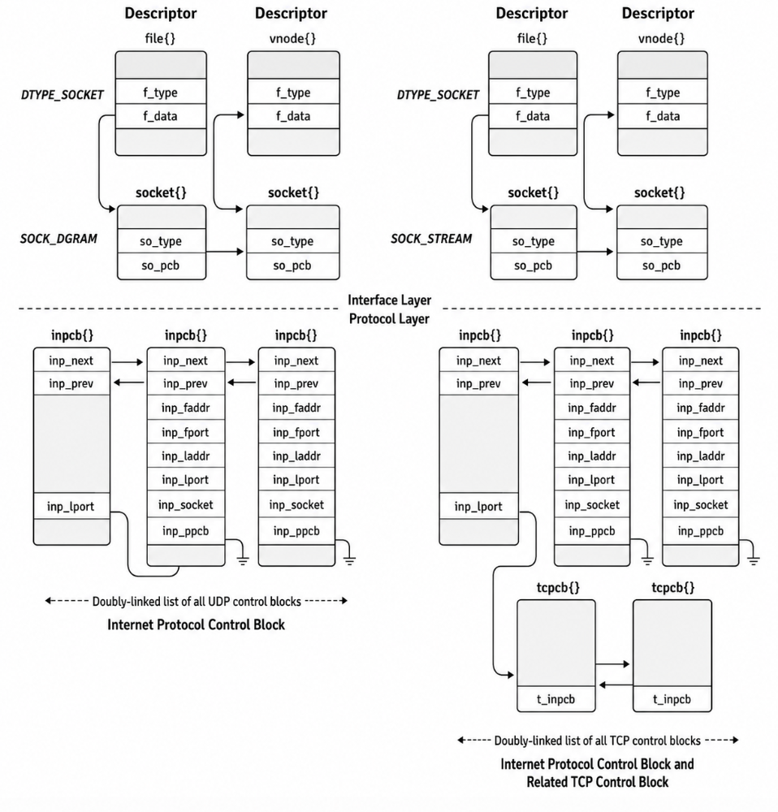
- Relationship among socket, Internet PCB and TCP control block. Original source: TCP/IP Illustrated, Vol. 2, Fig. 22-1 [1].
- Implementation Code Analysis

Major Modules and Entry Points
The TCP implementation is divided into several cooperating modules rather than a single monolithic procedure. The most important property of this design is that each module owns a different dimension of protocol processing. tcp_usrreq mediates socket-layer requests, tcp_input processes received segments, tcp_output constructs outgoing segments, tcp_timer handles time-driven events, tcp_subr provides attach, close, drop and template support, and tcp_ctlinput/tcp_ctloutput connect TCP to ICMP errors and socket options. This division matches the event sources of the protocol: user actions, incoming packets, timer expiration and control-plane notifications.

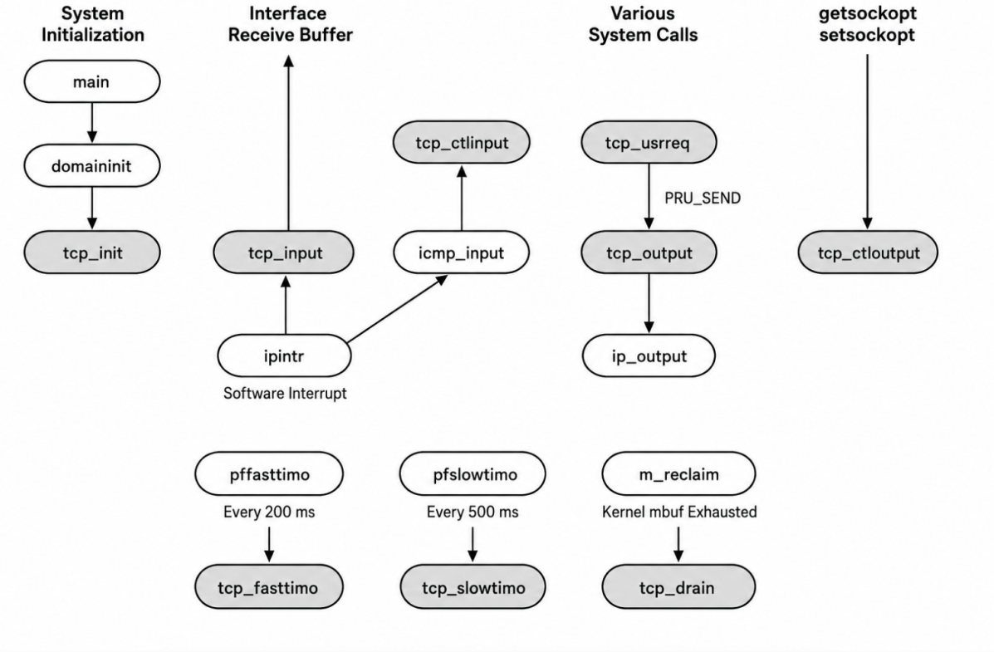
- TCP functions and their relation to other kernel functions. Original source: TCP/IP Illustrated, Vol. 2, Fig. 24-2 [1].
- TCP implementation modules and responsibilities.
Module | Primary entry source | Core responsibility
tcp_usrreq | Socket-layer PRU requests | Attaches and detaches TCP state, handles user operations such as bind, connect, send, shutdown and abort.
tcp_input | IP input path | Validates and demultiplexes received segments, advances the finite state machine, appends data and schedules ACKs.
tcp_output | User request, input reaction or timer | Chooses whether a segment may be sent, builds headers, observes send/receive windows and calls IP output.
tcp_timer / tcp_fasttimo / tcp_slowtimo | Periodic software timers | Implements delayed ACK, retransmission, persist, keep-alive and 2MSL timing behavior.
tcp_subr | Internal TCP helpers | Allocates, initializes, closes and drops TCP control blocks and maintains reusable protocol templates.
tcp_ctlinput / tcp_ctloutput | ICMP and socket options | Handles path/control errors and exposes or modifies transport-level options.

Header Format and Packet Construction
The TCP header carries the fields that allow both endpoints to interpret a byte stream as a sequence space: source port, destination port, sequence number, acknowledgement number, data offset, flags, advertised window, checksum and urgent pointer. Options extend the fixed 20-byte header when needed. In the BSD implementation, TCP commonly uses a combined IP/TCP header template to reduce repeated construction cost. This reflects a broader implementation principle: the stable part of a connection is cached in the control block, while dynamic fields such as sequence numbers, acknowledgements, flags and window advertisements are filled in during output.

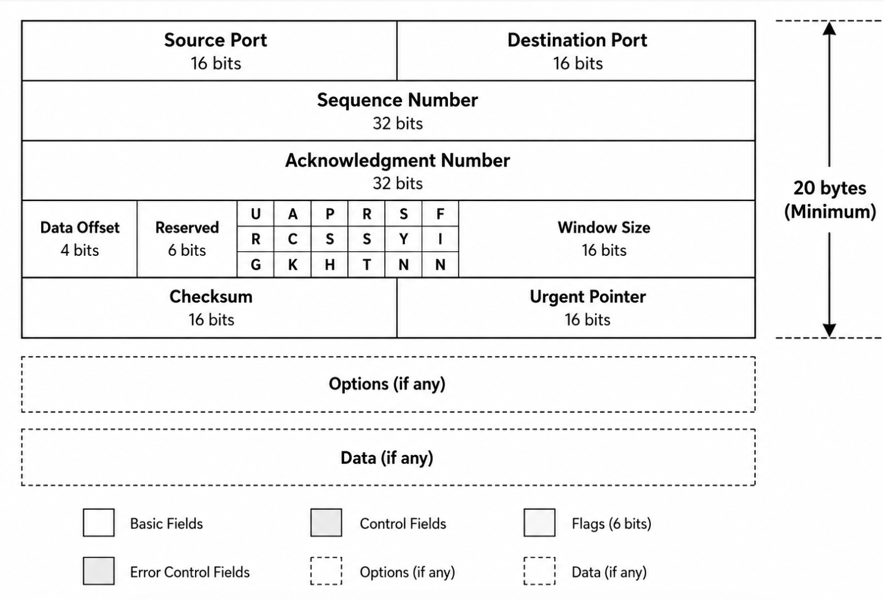
- TCP header and optional data. Original source: TCP/IP Illustrated, Vol. 2, Fig. 24-10 [1].
The checksum and pseudo-header dependency also show TCP interaction with IP. TCP is a transport protocol, but its checksum covers selected IP-layer information, including addresses and protocol number, to protect against misdelivery. Consequently, the TCP output path must know not only the byte-stream state but also the source and destination addresses stored in the Internet PCB. Conversely, TCP input cannot be analyzed independently from IP demultiplexing, because it relies on the incoming IP datagram to identify the protocol and endpoint tuple.
- Core Data Structures and State Management

Socket, Internet PCB and TCP Control Block
The central data structures form a layered state graph. The socket structure represents the process-visible communication endpoint. It contains option flags, state flags, connection queues and two socket buffers: so_rcv for incoming data and so_snd for outgoing data. The Internet PCB binds this endpoint to local and foreign IP addresses and ports and therefore supports bind, connect and demultiplexing. The TCP control block adds the data required by the transport protocol itself. Its fields are not ornamental; each group maps to a distinct protocol invariant.
- Core structures used by TCP in the BSD implementation.
Structure | Role in implementation | Important fields or concepts
socket | Protocol-independent endpoint referenced by a process descriptor. | so_type, so_options, so_state, so_pcb, so_rcv, so_snd and connection queues.
sockbuf | Kernel buffering object for receive and send directions. | Buffer occupancy, high-water marks, mbuf chain pointer and wakeup/select state.
inpcb | Internet protocol control block shared by TCP and UDP. | Local/foreign addresses and ports, cached route, IP options, socket pointer and transport PCB pointer.
tcpcb | TCP-specific per-connection control block. | State, timers, sequence variables, windows, retransmission variables, congestion variables and option state.
mbuf | Packet and socket-buffer memory unit. | Header mbufs, data mbufs, external clusters and linked chains for zero-copy-style sharing.
protosw | Protocol-switch entry linking the socket layer to TCP functions. | Input, output, user request, timer and control hooks.
Within tcpcb, the send sequence variables include snd_una, snd_nxt, snd_max and iss. snd_una is the oldest unacknowledged sequence number; snd_nxt is the next sequence number to send; snd_max records the highest sequence number transmitted; iss is the initial send sequence. The receive side has rcv_nxt, rcv_wnd, rcv_adv and irs. These variables embody TCP reliability and flow control. A segment cannot be accepted solely because it has a valid checksum; it must also fit the current receive sequence and window. Likewise, output is limited not only by application data availability but also by the receiver's advertised window and the sender's congestion window.
Timer state is another essential part of tcpcb. TCP relies on retransmission, persist, keep-alive and 2MSL timers. RFC 6298 defines the standard algorithm for computing retransmission timeout based on smoothed RTT and RTT variation [7]. The BSD code stores scaled estimators and backoff state in the control block so that timer behavior remains per-connection. This is a crucial design decision: packet loss and round-trip time are path-dependent, so a global timer would be too coarse to model multiple simultaneous TCP connections correctly.

Finite State Machine
TCP is usually introduced through the finite state machine, but in an implementation the state machine is not a diagram separate from code. The state variable t_state in tcpcb guides the interpretation of every incoming segment and every application operation. A SYN in LISTEN is a connection request; a SYN in ESTABLISHED is suspicious; a FIN in ESTABLISHED begins a half-close; an ACK in SYN_RECEIVED may complete the three-way handshake. The same flag therefore has different semantics depending on the connection state.
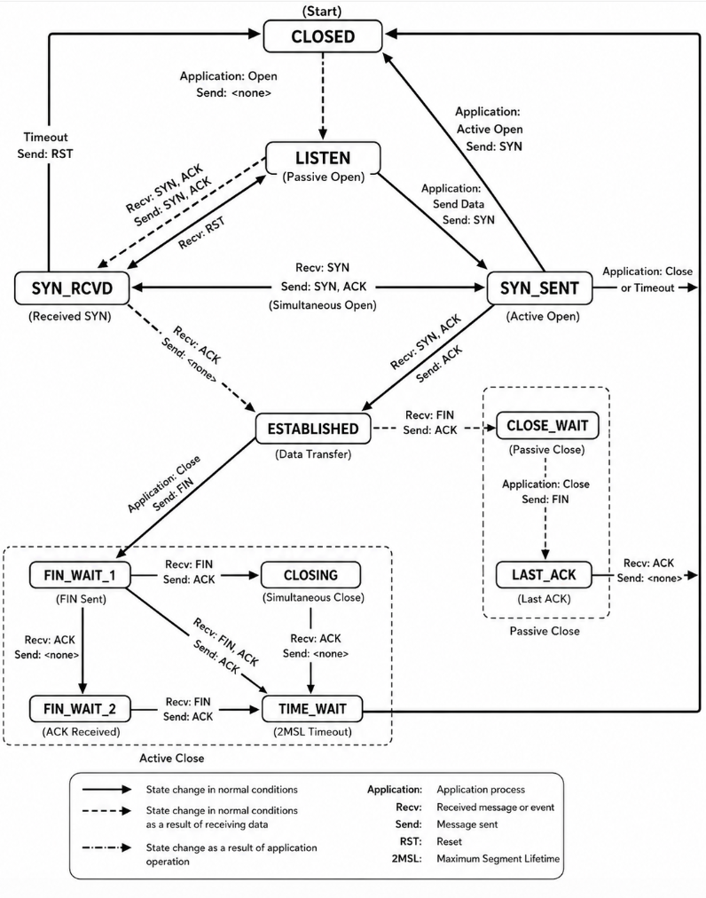
- TCP finite state transition diagram. Original source: TCP/IP Illustrated, Vol. 2, Fig. 24-15 [1].
The most important implementation lesson from the finite state machine is that connection management and data transfer are interleaved. For example, ESTABLISHED is the normal data-transfer state, but data may still arrive during shutdown states such as FIN_WAIT_1 or CLOSE_WAIT. Therefore, the implementation must not treat closing as an immediate deletion of all state. The TIME_WAIT state is also not a mere delay; it protects against old duplicate segments and ensures that the final acknowledgement can be retransmitted if necessary. This design consumes memory, but it is necessary for protocol correctness.
- Execution Flow and Module Coupling

Connection Establishment
For an active opener, the process calls connect. The socket layer validates the descriptor and passes the request to tcp_usrreq. TCP allocates or locates the Internet PCB, performs binding if no local port has been selected, initializes the TCP control block, records the foreign address and port, chooses an initial sequence number, and enters SYN_SENT. tcp_output then constructs and sends a SYN segment. For a passive opener, the process calls socket, bind and listen. The listening socket has SO_ACCEPTCONN set and maintains queues for embryonic and completed connections. When tcp_input receives a SYN for a listening endpoint, it creates a new socket and TCP control block for that connection rather than converting the listening socket into a connected socket.

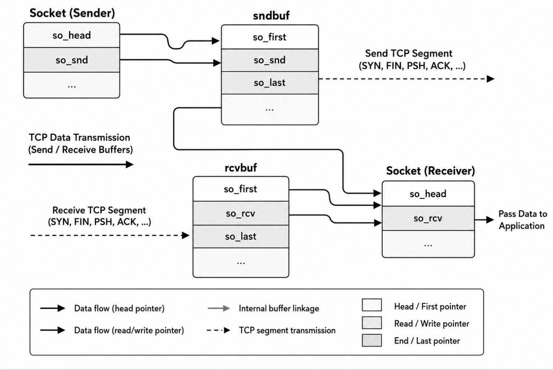
- Socket accept queues for pending and completed TCP connections. Original source: TCP/IP Illustrated, Vol. 2, Fig. 15-8 [1].
This queue structure explains how TCP supports concurrent connection establishment. Partially completed handshakes are held separately from established connections that are ready for accept. When the final ACK of the three-way handshake arrives, the newly created socket is moved to the completed queue and any process blocked in accept can be awakened. The design separates protocol progress from application scheduling: TCP can complete a handshake before the server process next executes.

Data Transmission and mbuf Flow
On output, application bytes enter the socket send buffer as mbuf chains. tcp_output decides how much data can be transmitted by comparing the available data, the maximum segment size, the advertised receive window and the congestion window. It then constructs an outgoing segment and passes it to IP. The BSD mbuf design is important because it avoids unnecessary copying. Data already present in a socket buffer can be referenced by another mbuf chain used for the interface output queue, while reference counts on external clusters protect memory lifetime.
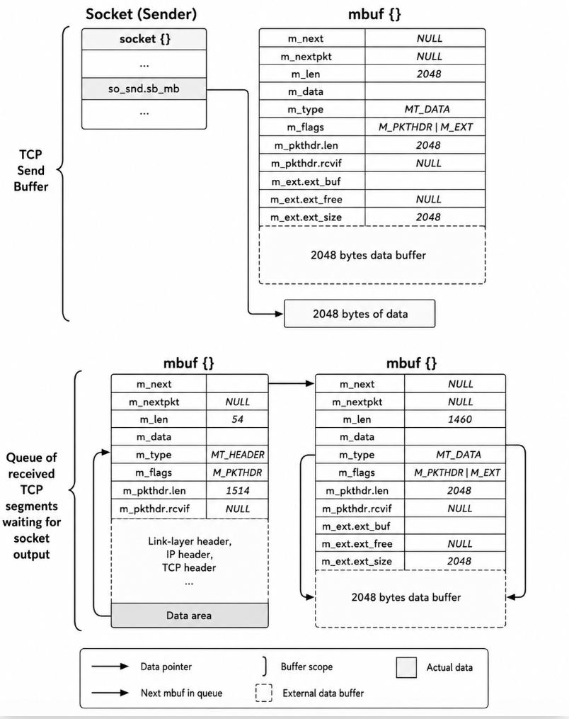
- TCP socket send buffer and interface output queue represented by mbuf chains. Original source: TCP/IP Illustrated, Vol. 2, Fig. 2-25 [1].
On input, IP delivers a TCP segment to tcp_input. The routine checks the header, finds the matching PCB, computes receive-window state, and then uses the connection state to choose the appropriate processing path. In the common fast path for in-sequence data with enough socket receive space, the implementation can remove TCP/IP headers, append data to so_rcv, wake up the receiving process and set a delayed-ACK flag. If the segment is out of order, outside the window or contains state-changing flags, the routine takes a slower path. This organization illustrates an early form of fast-path engineering: common cases are recognized explicitly, while exceptional or ambiguous cases are handled by more general logic.

Timers, ACKs and Congestion Feedback
TCP coupling is most visible around acknowledgements. An ACK both confirms reliable delivery and drives congestion-window growth. Duplicate ACKs may trigger fast retransmit. A delayed ACK reduces packet overhead but may also affect RTT measurement and sender pacing. The implementation therefore records flags such as TF_ACKNOW and TF_DELACK in tcpcb and executes periodic timer routines to transform postponed protocol obligations into actual output. Congestion control adds another layer: even when the receiver window allows more data, tcp_output must not exceed the congestion window. This is why sender state contains both snd_wnd and snd_cwnd.
Retransmission timers provide the recovery path when ACK-based recovery fails. RFC 6298 requires TCP senders to compute and manage retransmission timers using measured RTT and variance [7]. In the BSD-style design, a retransmission timeout backs off the timer, adjusts congestion variables and retransmits the oldest unacknowledged data. This behavior is conservative but safe. It prevents indefinite waiting, yet reduces the sender's rate to avoid increasing congestion after loss.
- Protocol Interactions Across Layers
TCP interacts with the application layer through the socket API. Application operations do not directly call tcp_input or tcp_output; they issue system calls that are translated into protocol requests. This boundary keeps applications portable while allowing the kernel to change internal implementation details. TCP also interacts with IP through both input and output paths. On output, TCP passes a segment to IP with a protocol number of 6 and relies on IP routing and interface selection. On input, IP demultiplexes datagrams to TCP, and TCP then demultiplexes by endpoint tuple to a PCB. The link layer remains below IP, but its maximum transmission unit affects TCP through MSS selection and segmentation behavior.
Control-plane interaction is also important. ICMP messages may report unreachable destinations, fragmentation problems or redirects. TCP cannot blindly expose every ICMP event to the application, because some errors are transient and some relate only to routing state. The BSD implementation handles these events through protocol control-input functions, connecting ICMP processing to TCP without merging the protocols. This separation matches the OSI layering model while acknowledging that real implementations must exchange information across layer boundaries.
- Layer interactions relevant to TCP implementation.
Layer or component | Interaction with TCP | Implementation significance
Application / socket API | connect, listen, accept, send, recv, shutdown and close. | User operations become PRU requests and manipulate socket buffers and TCP state.
Socket layer | Descriptor validation, generic buffers, connection queues and wakeups. | Allows TCP to share a uniform interface with other protocols.
Internet PCB | Endpoint tuple, cached route and IP options. | Supports binding, connecting and demultiplexing of received segments.
IP layer | Datagram input/output, routing and protocol number 6. | Provides unreliable packet delivery; TCP supplies reliability and ordering above it.
ICMP | Control errors and redirects. | Notifies TCP of path or peer problems through control-input hooks.
Interface / link layer | MTU, transmission queues and device drivers. | Constrains MSS and influences mbuf chain construction.
- Evaluation: Functionality, Performance, and Improvement Directions

Functional Correctness
A functionally correct TCP implementation must pass more than a simple connection test. The minimum functional set includes correct three-way handshake, duplicate detection, ordered delivery, retransmission after loss, flow-control enforcement, half-close semantics, reset handling and TIME_WAIT behavior. The 4.4BSD-Lite implementation is strong in this respect because protocol state is explicit and localized in tcpcb, while address and port demultiplexing are localized in inpcb. The separation reduces ambiguity: endpoint identity and transport state are related but not confused.
A practical validation plan can be derived from the implementation. A handshake test should verify transitions from CLOSED to SYN_SENT or LISTEN, then to ESTABLISHED. A data test should inject reordered or duplicated segments and confirm that only in-window, in-sequence data is delivered to the application. A retransmission test should drop a segment and observe retransmission timer behavior and congestion-window reduction. A close test should exercise active close, passive close and simultaneous close paths. These tests do not require pasting source code into the paper; they follow directly from the state variables and module responsibilities described above.

Performance Advantages and Limitations
The classic BSD implementation contains several effective performance ideas. It uses mbuf chains to avoid avoidable data copying, caches stable header information, separates fast and slow timer work, and recognizes common input cases. It also uses a one-behind PCB cache for recently active connections, which can reduce demultiplexing cost when packets from the same connection arrive in bursts. These choices are appropriate for the hardware and traffic assumptions of the original implementation and remain conceptually important in modern stacks.
The limitations are equally clear. A linear PCB search does not scale to very large numbers of concurrent connections. The implementation predates several widely deployed TCP extensions, including selective acknowledgements, stronger initial-sequence-number generation, modern high-performance timestamp and window-scale behavior, and time-based loss detection. The standards record illustrates these gaps: RFC 6528 strengthens ISN generation against off-path guessing attacks [8]; RFC 7323 specifies window-scale and timestamp extensions for high bandwidth-delay product paths [9]; RFC 2018 allows receivers to report non-contiguous data so senders can retransmit only missing segments [18]; RFC 8985 specifies RACK-TLP, a more modern loss-detection approach using transmit timestamps and SACK feedback [19].

Improvement Directions
Three improvement directions follow from the analysis. First, demultiplexing should use hash-based PCB lookup keyed by the four-tuple, while preserving correct wildcard handling for listeners. Second, loss recovery should incorporate SACK-based recovery and time-based loss detection, reducing dependence on retransmission timeout in the presence of multiple losses or tail loss. Third, security-sensitive defaults should reflect current standards, particularly for initial sequence number generation and reset handling. These improvements do not undermine the 4.4BSD-Lite design. Instead, they extend the same design pattern: add protocol state explicitly to the control block, keep policy decisions in TCP-specific code, and maintain the socket layer as a protocol-independent interface.
- Conclusion
This paper analyzed TCP as an implemented transport protocol rather than only as an abstract RFC state machine. In the 4.4BSD-Lite design, TCP service properties are realized through a carefully connected set of data structures: the process descriptor reaches a socket; the socket reaches an Internet PCB; the Internet PCB identifies the endpoint tuple and links to the TCP control block; the TCP control block carries sequence, window, timer, state and congestion variables; mbuf chains carry data between socket buffers and IP output. The major routines are similarly differentiated: tcp_usrreq translates user requests, tcp_input interprets network events, tcp_output constructs segments, and timer routines enforce time-dependent protocol obligations.
The analysis shows that TCP correctness depends on the consistency of this entire state graph. Reliability, ordering, flow control and congestion response are not implemented by isolated mechanisms; they cooperate through shared per-connection state. The BSD implementation is historically important because it demonstrates these mechanisms in a readable, modular kernel architecture. Its limitations, such as linear PCB search and the absence of later loss-recovery and security extensions, are understandable in historical context and provide clear directions for modernization. For learning TCP/IP design and implementation, TCP remains one of the most complete examples of how protocol specification, operating-system interfaces and kernel data structures converge in a real network stack.

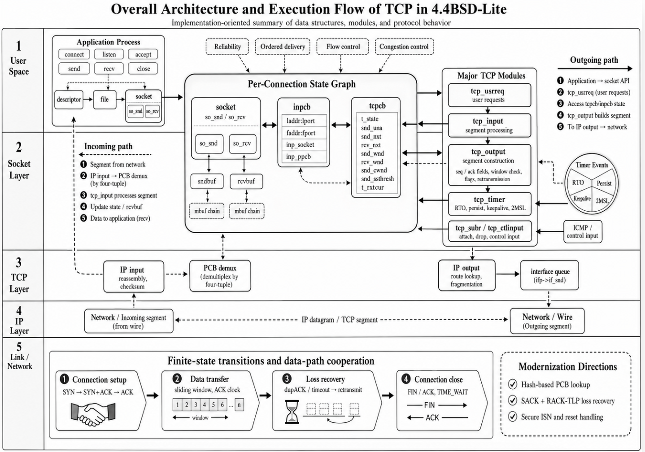
Figure 9 Overall Architecture and Execution Flow of TCP in 4.4BSD-Lite
- References
- G. R. Wright and W. R. Stevens, TCP/IP Illustrated, Volume 2: The Implementation, Addison-Wesley, Reading, MA, 1995.
- W. R. Stevens, TCP/IP Illustrated, Volume 1: The Protocols, Addison-Wesley, Reading, MA, 1994.
- W. Eddy, “Transmission Control Protocol (TCP),” IETF RFC 9293, DOI: 10.17487/RFC9293, Aug. 2022.
- J. Postel, “Transmission Control Protocol,” IETF RFC 793, DOI: 10.17487/RFC0793, Sep. 1981.
- R. Braden, “Requirements for Internet Hosts - Communication Layers,” IETF RFC 1122, DOI: 10.17487/RFC1122, Oct. 1989.
- M. Allman, V. Paxson, and E. Blanton, “TCP Congestion Control,” IETF RFC 5681, DOI: 10.17487/RFC5681, Sep. 2009.
- V. Paxson, M. Allman, J. Chu, and M. Sargent, “Computing TCP’s Retransmission Timer,” IETF RFC 6298, DOI: 10.17487/RFC6298, Jun. 2011.
- F. Gont, “Defending against Sequence Number Attacks,” IETF RFC 6528, DOI: 10.17487/RFC6528, Feb. 2012.
- D. Borman, B. Braden, V. Jacobson, and R. Scheffenegger, “TCP Extensions for High Performance,” IETF RFC 7323, DOI: 10.17487/RFC7323, Sep. 2014.
- M. Duke, R. Braden, W. Eddy, E. Blanton, and A. Zimmermann, “A Roadmap for Transmission Control Protocol (TCP) Specification Documents,” IETF RFC 7414, DOI: 10.17487/RFC7414, Feb. 2015.
- V. Jacobson, “Congestion Avoidance and Control,” ACM SIGCOMM Computer Communication Review, vol. 18, no. 4, pp. 314-329, DOI: 10.1145/52325.52356, 1988.
- 4.4BSD-Lite2 Source Tree, “sys/netinet/tcp_input.c,” Available at: https://github.com/chenshuo/4.4BSD-Lite2/blob/master/sys/netinet/tcp_input.c, accessed 2026-06-17.
- 4.4BSD-Lite2 Source Tree, “sys/netinet/tcp_output.c,” Available at: https://github.com/chenshuo/4.4BSD-Lite2/blob/master/sys/netinet/tcp_output.c, accessed 2026-06-17.
- 4.4BSD-Lite2 Source Tree, “sys/netinet/tcp_usrreq.c,” Available at: https://github.com/chenshuo/4.4BSD-Lite2/blob/master/sys/netinet/tcp_usrreq.c, accessed 2026-06-17.
- 4.4BSD-Lite2 Source Tree, “sys/netinet/tcp_timer.c,” Available at: https://github.com/chenshuo/4.4BSD-Lite2/blob/master/sys/netinet/tcp_timer.c, accessed 2026-06-17.
- 4.4BSD-Lite2 Source Tree, “sys/netinet/tcp_var.h,” Available at: https://github.com/chenshuo/4.4BSD-Lite2/blob/master/sys/netinet/tcp_var.h, accessed 2026-06-17.
- 4.4BSD-Lite2 Source Tree, “sys/netinet/tcp_fsm.h,” Available at: https://github.com/chenshuo/4.4BSD-Lite2/blob/master/sys/netinet/tcp_fsm.h, accessed 2026-06-17.
- M. Mathis, J. Mahdavi, S. Floyd, and A. Romanow, “TCP Selective Acknowledgment Options,” IETF RFC 2018, DOI: 10.17487/RFC2018, Oct. 1996.
- Y. Cheng, N. Cardwell, N. Dukkipati, and P. Jha, “The RACK-TLP Loss Detection Algorithm for TCP,” IETF RFC 8985, DOI: 10.17487/RFC8985, Feb. 2021.

